Лекция 27
ПСКП
ПОИТ-3

Протокол WebDAV

- WebDAV: Web Distributed Authoring and Versioning – расширение протокола HTTP/HTTPS, поддерживающее совместную работу по управление файлами на удаленных web-северах; применяется для создания сетевой файловой системы; в системах документооборота (document management system).
- WebDAV: альтернатива FTP, SMB.
- WebDAV: OS X (Apple) iDisk, Яндекс.Диск, Box.net, Google Drive, Amazon Microsoft IIS, Apache HTTP Server, Dropbox.
- WebDAV: в Windows WebDAV API C++.
- WebDAV: унаследованные HTTP-методы
- WebDAV: GET – скачать файл.
- WebDAV: PUT – загрузить файл на сервер.
- WebDAV: DELETE – удалить серверный объект.
- WebDAV: RFC 2291, RFC 4918, RFC 3648, RFC 3744, RFC 3253.
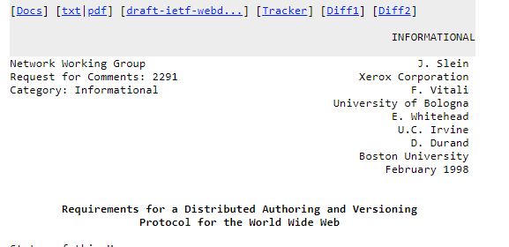
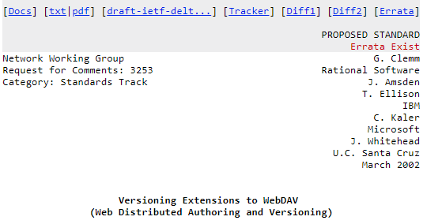
- WebDAV: RFC 3253
- WebDAV RFC 3253: BASELINE-CONTROL
- WebDAV RFC 3253: CHECKOUT
- WebDAV RFC 3253: CHECKIN
- WebDAV RFC 3253: LABEL
- WebDAV RFC 3253: MERGE
- WebDAV RFC 3253: MKACTIVITY
- WebDAV RFC 3253: MKWORKSPACE
- WebDAV RFC 3253: REPORT
- WebDAV RFC 3253: UNCHECKOUT
- WebDAV RFC 3253: UPDATE
- WebDAV RFC 3253: VERSION-CONTROL

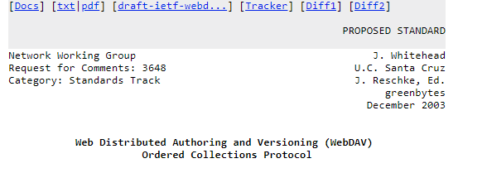
- WebDAV: RFC 3648
- WebDAV RFC 3648: ORDERPATH

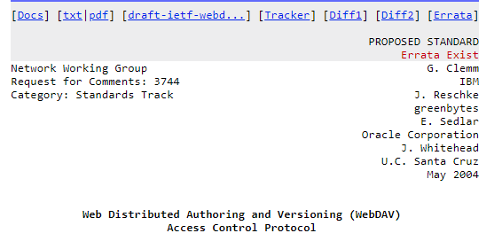
- WebDAV: RFC 3744
- WebDAV RFC 3744: ACL

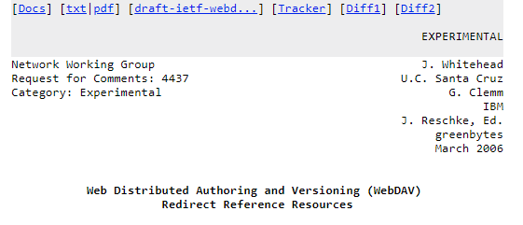

- WebDAV: RFC 4437
- WebDAV RFC 4437: UPDATEREDIRECTREF

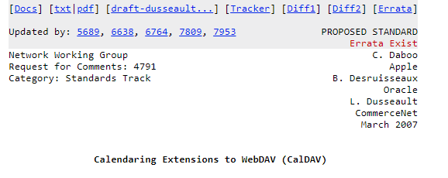

- WebDAV: RFC 4791
- WebDAV RFC 4791: MKCALENDAR

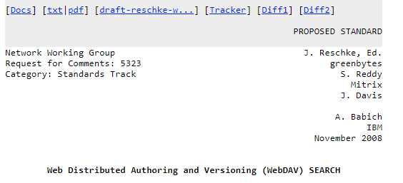

- WebDAV: RFC 5323
- WebDAV RFC 5323: SEARH

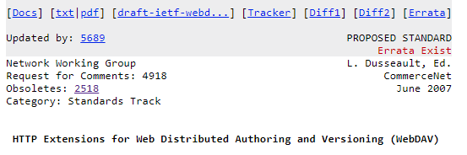

- WebDAV RFC 5618: PROPFIND – получить свойства серверного объекта в XML-формате.
- WebDAV RFC 5618: PROPPATCH – изменить свойства серверного объекта.
- WebDAV RFC 5618: MKCOL – создать папку на сервере.
- WebDAV RFC 5618: COPY – копировать на сервере.
- WebDAV RFC 5618: MOVE – переместить на сервере.
- WebDAV RFC 5618: LOCK – заблокировать серверный объект.
- WebDAV RFC 5618: UNLOCK – разблокировать серверный объект.

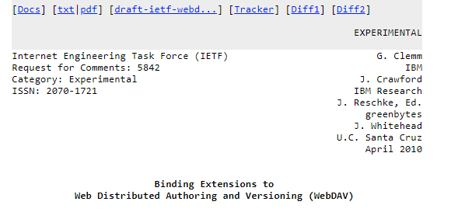

- WebDAV RFC 5842: BIND.
- WebDAV RFC 5842: REBIND.
- WebDAV RFC 5842: UNBIND.

- WebDAV: Яндекс.Диск
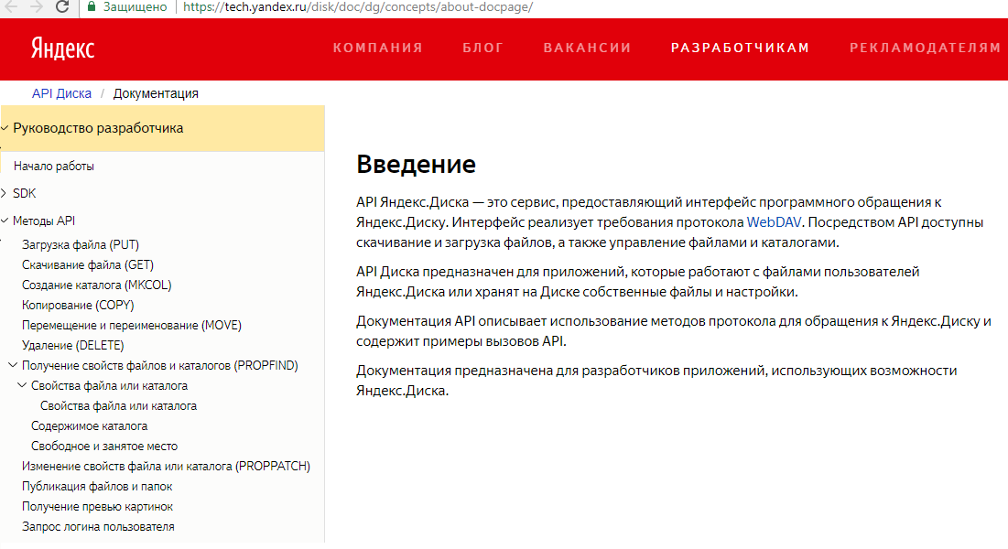

- WebDAV: Яндекс.Диск, зарегистрироваться и получить имя и пароль
- WebDAV: Яндекс.Диск - создать папку
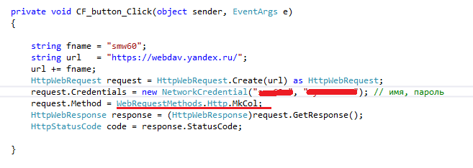
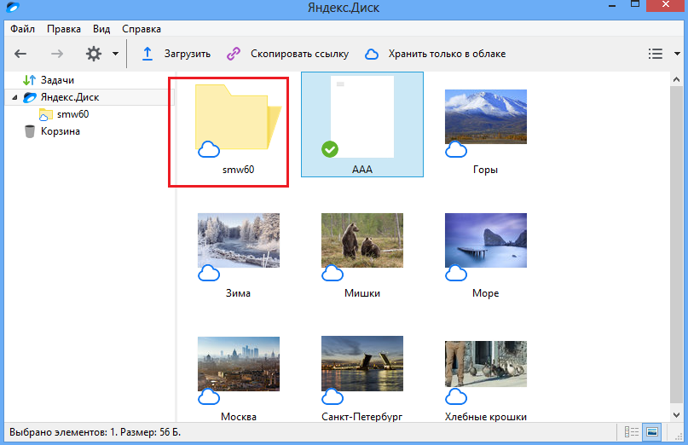

- WebDAV: Яндекс.Диск - скачать файл
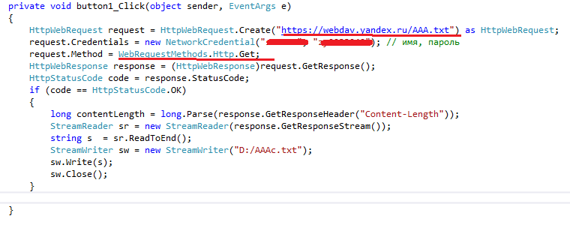

- WebDAV: Яндекс.Диск - удалить файл
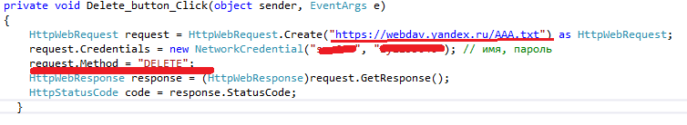

- WebDAV: Яндекс.Диск - удалить папку
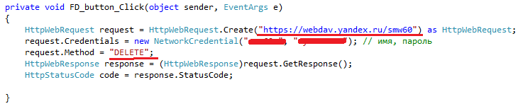

- Методы
- HTTP Request Methods
- The following 39 HTTP Request Method values were found in all available webconcepts.infospecifications. Please be advised that the table shown here is maintained and compiled from Web Concepts sources. The official HTTP Request Method registry is maintained by the Internet Assigned Numbers Authority (IANA).
HTTP Request Method | Specification
ACL | RFC 3744: Web Distributed Authoring and Versioning (WebDAV) Access Control Protocol
BASELINE-CONTROL | RFC 3253: Versioning Extensions to WebDAV (Web Distributed Authoring and Versioning)
BIND | RFC 5842: Binding Extensions to Web Distributed Authoring and Versioning (WebDAV)
CHECKIN | RFC 3253: Versioning Extensions to WebDAV (Web Distributed Authoring and Versioning)
CHECKOUT | RFC 3253: Versioning Extensions to WebDAV (Web Distributed Authoring and Versioning)
CONNECT | RFC 7231: Hypertext Transfer Protocol (HTTP/1.1): Semantics and Content
COPY | RFC 4918: HTTP Extensions for Web Distributed Authoring and Versioning (WebDAV)
DELETE | RFC 7231: Hypertext Transfer Protocol (HTTP/1.1): Semantics and Content
GET | RFC 7231: Hypertext Transfer Protocol (HTTP/1.1): Semantics and Content
HEAD | RFC 7231: Hypertext Transfer Protocol (HTTP/1.1): Semantics and Content
LABEL | RFC 3253: Versioning Extensions to WebDAV (Web Distributed Authoring and Versioning)
LINK | Internet Draft snell-link-method: HTTP Link and Unlink Methods
LOCK | RFC 4918: HTTP Extensions for Web Distributed Authoring and Versioning (WebDAV)
MERGE | RFC 3253: Versioning Extensions to WebDAV (Web Distributed Authoring and Versioning)
MKACTIVITY | RFC 3253: Versioning Extensions to WebDAV (Web Distributed Authoring and Versioning)
MKCALENDAR | RFC 4791: Calendaring Extensions to WebDAV (CalDAV)
MKCOL | RFC 4918: HTTP Extensions for Web Distributed Authoring and Versioning (WebDAV)
MKREDIRECTREF | RFC 4437: Web Distributed Authoring and Versioning (WebDAV): Redirect Reference Resources
MKWORKSPACE | RFC 3253: Versioning Extensions to WebDAV (Web Distributed Authoring and Versioning)
MOVE | RFC 4918: HTTP Extensions for Web Distributed Authoring and Versioning (WebDAV)
OPTIONS | RFC 7231: Hypertext Transfer Protocol (HTTP/1.1): Semantics and Content
ORDERPATCH | RFC 3648: Web Distributed Authoring and Versioning (WebDAV) Ordered Collections Protocol
PATCH | RFC 5789: PATCH Method for HTTP
POST | RFC 7231: Hypertext Transfer Protocol (HTTP/1.1): Semantics and Content
PRI | RFC 7540: Hypertext Transfer Protocol Version 2
PROPFIND | RFC 4918: HTTP Extensions for Web Distributed Authoring and Versioning (WebDAV)
PROPPATCH | RFC 4918: HTTP Extensions for Web Distributed Authoring and Versioning (WebDAV)
PUT | RFC 7231: Hypertext Transfer Protocol (HTTP/1.1): Semantics and Content
REBIND | RFC 5842: Binding Extensions to Web Distributed Authoring and Versioning (WebDAV)
REPORT | RFC 3253: Versioning Extensions to WebDAV (Web Distributed Authoring and Versioning)
SEARCH | RFC 5323: Web Distributed Authoring and Versioning (WebDAV) SEARCH
TRACE | RFC 7231: Hypertext Transfer Protocol (HTTP/1.1): Semantics and Content
UNBIND | RFC 5842: Binding Extensions to Web Distributed Authoring and Versioning (WebDAV)
UNCHECKOUT | RFC 3253: Versioning Extensions to WebDAV (Web Distributed Authoring and Versioning)
UNLINK | Internet Draft snell-link-method: HTTP Link and Unlink Methods
UNLOCK | RFC 4918: HTTP Extensions for Web Distributed Authoring and Versioning (WebDAV)
UPDATE | RFC 3253: Versioning Extensions to WebDAV (Web Distributed Authoring and Versioning)
UPDATEREDIRECTREF | RFC 4437: Web Distributed Authoring and Versioning (WebDAV): Redirect Reference Resources
VERSION-CONTROL | RFC 3253: Versioning Extensions to WebDAV (Web Distributed Authoring and Versioning)

- тт
- тт
- тт
- тт

